Treasurers Report

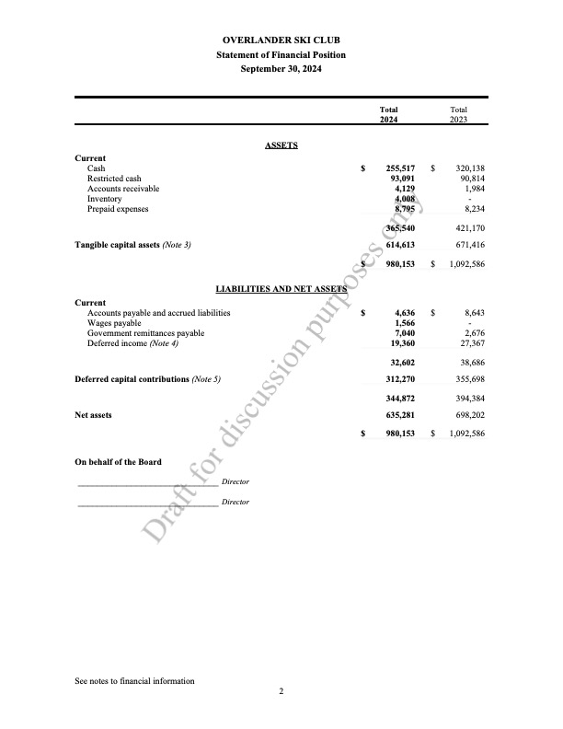
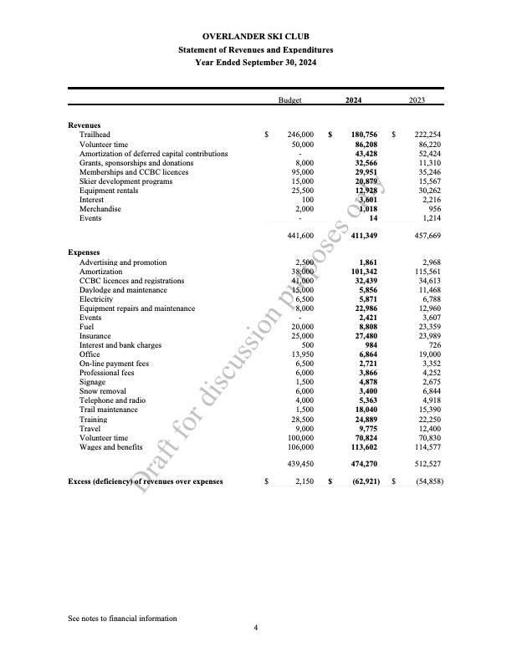

A quick analysis of the statements shows that the financial position of the club is strong:
- We started the year with a total of $349k of cash, of which $93k was considered to be restricted due to it being invested in a short-term GICs.
- Our tangible capital assets balance is showing as decreasing year over year, mostly due to regular amortization being taken (not large asset disposals).
- When you put cash assets up against accounts payable of $13k, the financial position is quite strong.
- Looking at the Statement of Revenue and Expenses, it shows we had a $63k loss on the year. However, this includes non-cash amortization expenses of $101k. For those that don't speak accountant, amortization is an annual expense taken over the life of capital assets that the club continues to own at the end of any month/year. Amortization is a non-cash expense, meaning it isn't a cash outlay. For example, buy an asset with a 10 year life for $100k, and you'll have an annual amortization expense of $10k. For most companies that have capital assets, if you're losing money after all expenses (such as we are at a $63K loss), at some point you'll need to borrow or inject money to replace capital assets. So to think about it another way, if we continue to operate at a loss, we won't have enough cash to replace our capital assets such as our groomer and buildings, assuming that we can purchase those assets in the future at the price we bought them for.

