|  |  |  |
| --- | --- | --- |
|  | **STAKE LAKE CROSS COUNTRY**  **SKI AND SNOWSHOE TRAILS** | |
| A snow covered road at night  Description automatically generated  Heavy snow on opening day Nov 29th 2022 | |



**STAKE LAKE SKI AND SNOWSHOE TRAILS operated by OVERLANDER SKI CLUB**

**Executive Summary of Trails Operations in 2022-2023**

**September 2023**

Our 32nd year of operations was a great improvement when compared to the year before. Snow conditions were excellent from our early start in late November to the end of March. Despite two spells of cold temperatures the demand for skiing and snowshoeing was much improved. Snowfalls were frequent and the snow depths were unusually high. Our attendance rose to 22,909 skiers and 1,982 snowshoers from 16,196 skiers and 1,774 snowshoers last season.

Winter conditions arrived early with snow on the trails by the end of October. Trails were packed after substantial snowfalls in November, but staffing problems meant that the trails were not opened until the end of the month. Conditions were excellent but a cold front at Christmas severely limited attendance over the holiday for the second year in succession. Another cold spell in February further affected trail numbers. We were open for 118 days, well above our 30-year average.

Fees were again unchanged from the previous year. Revenues declined to $226,129. Trail operating expenses increased substantially to $241,172. Depreciation was estimated at $38,000 resulting in total trail costs of $279,172. Net revenue was $(53,043). Costs were kept low by using many hours of volunteer labour. The estimated value of labour donations was $50,000. The total net value of assets held by the club and used to operate the trails is $1 million. The total value of investments made by the Club since 1991 is approximately $1,620,000.

Trail use was promoted through the Club web page, participation in local tourism promotions and media releases and through Cross Country BC magazine.

The new snow groomer performed well after extensive training and use of both the new and old grooming machines allowed the trails to be packed and tracked after snowfalls much faster than in the past. Many volunteer hours were spent grooming track and maintaining equipment.

The “off-piste” trails and an additional snowshoe trail were completed, and new trail signs ordered and installed. Further trail “smoothing” took place throughout the trails with the aim of improving early season skiing.

The trail system was used for teaching skiers of all ages and abilities. Special rates were again offered to all college students. The Ski S’Kool program was the most successful ever with 1727 children. The children ski at no charge and the program costs are absorbed by Overlander. The club also cooperated with the City of Kamloops to hold adult ski sessions which were advertised in the City Recreation brochure. Overlander hosted the cross-country skiing portion of the BC Winter Special Olympics with 27 participants, and an Okanagan Teck Cup with 125 skiers.

The Lights display was expanded and advertised. A free snowshoe day sponsored by Pacific Sport and was very successful. Another successful Snowshoe event was held by the Dirty Feet company.

We were awarded gold in the Best in Kamloops competition. Locals participate in an online vote for their favourite sports and recreation facility and we were kindly awarded #1!

Overlander Ski Club has served 392,045 skiers since 1991 and 17,543 snowshoers since 2007. We plan to continue serving the people of the Kamloops area and the province in the 2023-2024 year.

***Table of Contents***

EXECUTIVE SUMMARY

REPORT

|  |  |  |
| --- | --- | --- |
| 1) |  | INTRODUCTION |
| 2) |  | OVERLANDER SKI CLUB |
| 3) |  | MANAGEMENT COMMITTEE |
| 4) |  | MARKETING |
| 5) |  | PARTNERSHIP AGREEMENT ADMINISTRATION |
| 6) |  | TRAIL USE |
| 7) |  | FINANCIAL SUMMARY |
| 8) |  | STAFF |
| 9) |  | TRAIL CONSTRUCTION AND MAINTENANCE |
| 10) |  | TREE REMOVAL AND LOGGING |
| 11) |  | TRAIL GROOMING |
| 12) |  | SNOW REMOVAL |
| 13) |  | EQUIPMENT |
| 14) |  | BUILDINGS |
| 15) |  | PROGRAMS and EVENTS |
| 16) |  | SKI AND SNOWSHOE RENTAL |
| 17) |  | SAFETY |
| 18) |  | SECURITY |
| 19) |  | CUSTOMER SUGGESTIONS |
| 20) |  | RECOMMENDATIONS |
| 21) |  | ACKNOWLEDGMENTS |

APPENDICES

1. FINANCIAL SUMMARY
2. TRAIL USE BY USER CATEGORY
3. TRAIL PHOTOS
4. TRAIL FEES 2022-23

**Stake Lake Ski and Snowshoe Trails Annual Report for 2022-23**

**1) INTRODUCTION**

Overlander Ski Club operates the Stake Lake Ski and Snowshoe Trails under contract with Recreation Sites and Trails BC. The contract requires the club to produce an Annual Report on the operation of the trails. This report must provide the management agency with the information necessary to monitor and audit the performance of the Overlander Ski Club in relation to the approved management goals.

Our management goals for the 2022-23 ski season, as in previous years, were:

1. To operate the Stake Lake Ski and snowshoe Trails in such a way that our customers, regardless of ability, enjoy a safe high-quality experience each time they use the trails.
2. To promote the use of the ski and snowshoe trails by Kamloops residents, other area residents, and visitors to the area.
3. To improve the ski and snowshoe facilities and trail maintenance equipment through volunteer efforts, public fund raising, and reinvestment of operating surpluses to raise the quality of the skiing experience in the coming year and in future years.

Overlander strives to provide facilities and programs that are a clear benefit to the Citizens of Kamloops and the surrounding area, and to our many visitors from afar. Our facilities are available to anyone regardless of age, ability, ethnicity, gender, religion, income or sexual orientation. We engage in long term planning to ensure that our programs and facilities are sustainable for the next generation.

Overlander wishes to thank our many supporters in the local community and financial contributions from government funding agencies.

The Annual Report is intended to provide the management agency with information to assess performance of the ski trail operation.

**2) OVERLANDER SKI CLUB**

The Overlander Ski Club is a registered, non-profit society and has operated in the Kamloops area since 1981. The objectives of the Ski Club are to foster cross country skiing and ski racing and to assist in the development of skiers in the Kamloops area. The 2022-23 membership was 1417 persons, a 17% decrease from last year.

In the early 1980’s, the club played a major role in the campaign to seek compensation for the destruction of the Bush Lake/Timber Lake ski trails during the construction of the Coquihalla Highway. This campaign led to the construction of the Stake Lake Ski Trails in 1986. Following a public competition, a trails operating contract was offered to Lac Le Jeune Resort. Over the next few years, the club made numerous representations to the public management agencies concerning the poor performance of the contractor and the condition of the trails. When the contractor declined the obligatory offer of a new contract in 1991, the club was asked to manage the trails. The membership agreed, but not without many misgivings. The financial and organisational commitments were thought to be close to the limit of our capability, given our status as a voluntary organisation without previous experience in the field.

Since 1991 the Overlander Ski Club has operated the trails with growing confidence under contract with the Provincial Government. The current contract, called a Partnership Agreement, which expired May 15, 2033 and has been renewed for an additional 10 yr term ending May 15, 20233 . Public support has been strong, club membership has grown, and after 30 seasons of operations, the quality of the Stake Lake skiing experience is second to none in the province. The club continues to rely upon a dedicated group of volunteers to manage the trails along with a small number of paid staff. The value of volunteer time over the past season is estimated to be $50,000 which is about 50% of the expense of paid staff.

**3) TRAIL MANAGEMENT COMMITTEE**

Responsibility for the operation of the trail system rests with a Trail Management Committee which reports to the Executive of the Overlander Ski Club.

The 2022-23 Committee members and their responsibilities were as follows:

Thomas Bennett Trails, Track Preparation

Tim Cole Committee chair; Snowshoe trails, Grooming Lead

Chelsea Francis Staff

Luke Guilherme Equipment and track preparation; OSC Executive

Chris Jones Equipment and track preparation

Klaus Mey Trail maintenance, OSC Executive

Stew Stankiewicz Trails, Track Preparation

Alan Vyse Trails

The 2022-2023 Executive committee of Overlander Ski Club was follows:

Jen Stuart President

Charlene Eden Vice President

Kailee Mortimer Secretary

Dave Hallinan Treasurer

Cheryl Beattie Ways and Means

Joan Bernard Director - Membership

Luc Guilherme Director - Trails

Klaus Mey Director - Volunteers

Dana Manhard Director - Junior Programs

Rich McCleary Director - Ski League

Brad Smith Director – At large

**4) MARKETING**

Our marketing efforts continue to develop an enhanced level of awareness of the Stake Lake Trails, Overlander Ski Club, and cross-country skiing in general, in the Kamloops area. Our primary medium for marketing is the Club web page.

We also sought publicity for the trails through various promotions. The pre-season ski events, the trail opening day and ski lessons were publicized on radio and TV and in local newspapers and social media.

The Club Web Page (www.overlanderskiclub.com) now serves as the principal means of serving our members and promoting the club and the trails system to others. The web page was updated daily during the ski season. A web camera and automatic weather station allow members and visitors to check trail conditions. Ski Trail and Snowshoe Trail maps are available for download and were distributed free of charge to patrons. Geo-referenced PDF trail maps are available on trail applications for cell phones.

Snow conditions were reported daily to area residents through the web page (http://www.overlanderskiclub.com/), our staff and our Snow Phone answering machine (250-374-5514). The trails are also featured on the Snow Forecast site ([www.snowforecast.com](http://www.snowforecast.com)).

Thanks to Pacific Sport we held a free Snowshoeing day with 159 participants.

The Nordic Pulse app was to allow members to get up to the minute information on trail conditions.

**5) PARTNERSHIP AGREEMENT ADMINISTRATION**

On Dec 2001, Overlander Ski Club signed a Recreational Trail Management Agreement with the B.C. Forest Service, Kamloops Forest District under authority of Section 170 of the Forest Practices Code of British Columbia Act. The term of the agreement was 10 years. In 2006, management responsibility for the trails was transferred to the Ministry of Tourism, Sports and the Arts, and then the Ministry of Tourism, Culture and the Arts. In 2010, responsibility was transferred to the Ministry of Forests, Lands and Natural Resource Operations. The club signed a second 10-year agreement with Recreation Sites and Trails BC, which is part of the Ministry, in November 2011. In 2013 the form of the Trail management Agreement changed, and a Partnership Agreement was offered to the Club by Recreation Sites and Trails BC and signed December 2013. This agreement ended in May 2023 and has been re-negotiated for an addition 10 year term ending May 15, 2023 .

**6) TRAIL USE**

The trails were open for a total of 118 days from November 26th,2022 to March 26th, 2022, and there were three closed days in the week before Christmas for cold weather. Trails were open 8 am to 8 pm from Monday to Saturday and until 4pm on Sunday.

Snow arrived early, and there were two lengthy periods of cold weather in December during the Christmas period, and in February which sharply reduced attendance. Snow conditions were excellent throughout the season.

A total of 22,909 skier days were recorded for the year with an average of 194 skier visits per day and 1982 snowshoer visits were recorded. These totals are below the record seasons of two years ago but well above average. Use of the snowshoe trails did not increase as much as ski use.

The greatest use of the trails occurred on weekends, with Saturday the busiest day. The highest day attendance was 495 on February 11th. The highest weekly total of the year (2469 skiers) occurred immediately following New Year. Night use of the trails increased slightly to 2492. starting on Jan 2nd and continued to March 9th. Night-time attendance contributed about 11% to the total attendance suggesting a relative decline in the popularity of night skiing.

We know that the total number of skiers is more than the recorded total because members and others ski before the trails open and after they close; and a few people use the trails without paying. Opening at night has allowed us to capture some of those who used to ski after hours. In addition, our staff members are often on duty well before official opening time and regularly greet early morning skiers. Most of the skiers who ski before or after hours are club members. This season there were many skiers on the trails before the trails opened because the snow arrived much earlier than usual. The trails were rolled and packed about two weeks before staff were available for an official opening and many experienced members took advantage of the early snow. There was also some minor use after the trails were closed at the end of the season. Although entry to the trails from access points at the south end of the trails is less because of fencing on the south end of the trails, customers continue to use the Dog trails without checking at the ticket booth.

We sold a total of 1366 season passes, including 65 family passes, 75 parent passes and 40 snowshoe passes. Season pass sales were 1% more than last year. 318 six-day ski passes, 4540 one-day ski passes, 4 six-day snowshoe passes and 1563 one-day snowshoe passes were sold. School visits increased substantially to a record of 1727 student days even after cold weather led to the cancellation of several sessions.

Two free skiing days were held this season: at the beginning of the season and on Family Day, Feb 20th. On Family Day, our staff collected cash and food supplies in lieu and the Club made a substantial donation to the Kamloops Food Bank.

## Ski Trail use in 2022-23 compared with previous seasons

The following tables show daily ski and snowshoe trail use during the season. The accompanying graph compares trail use in the 2021-22 season compared with yearly use over the previous 30 years that the trails have been under Overlander Ski Club management. Mean attendance is 14,198 skiers per year and the total number of skier days from inception is 369,136. The total number of snowshoe trail users is 14,782 over 10 seasons.

**Daily ski trail use**

|  |  |  |  |  |  |  |  |  |
| --- | --- | --- | --- | --- | --- | --- | --- | --- |
| Date | Sun | Mon | Tues | Wed | Thurs | Fri | Sat | weekly total |
| 20-Nov |  |  |  |  |  |  | 306 |  |
| 27-Nov | 290 | 46 | 26 | 62 | 15 | 20 | 202 | 661 |
| 04-Dec | 290 | 69 | 83 | 89 | 92 | 160 | 248 | 1031 |
| 11-Dec | 232 | 80 | 66 | 128 | 104 | 146 | 273 | 1029 |
| 18-Dec | 22 | 16 | 0 | 0 | 0 | 102 | 334 | 474 |
| 25-Dec | 148 | 225 | 90 | 34 | 410 | 243 | 448 | 1598 |
| 01-Jan | 446 | 380 | 219 | 232 | 292 | 415 | 485 | 2469 |
| 08-Jan | 387 | 155 | 288 | 264 | 267 | 189 | 405 | 1955 |
| 15-Jan | 317 | 177 | 204 | 194 | 318 | 196 | 450 | 1856 |
| 22-Jan | 445 | 182 | 185 | 183 | 89 | 223 | 396 | 1703 |
| 29-Jan | 136 | 125 | 140 | 135 | 270 | 220 | 381 | 1407 |
| 05-Feb | 318 | 112 | 197 | 187 | 202 | 204 | 495 | 1715 |
| 12-Feb | 221 | 97 | 165 | 157 | 208 | 149 | 337 | 1334 |
| 19-Feb | 166 | 303 | 53 | 31 | 25 | 52 | 332 | 962 |
| 26-Feb | 308 | 199 | 209 | 196 | 213 | 219 | 287 | 1631 |
| 05-Mar | 325 | 139 | 153 | 148 | 184 | 119 | 334 | 1402 |
| 12-Mar | 264 | 30 | 63 | 81 | 62 | 107 | 158 | 765 |
| 19-Mar | 173 | 64 | 31 | 60 | 30 | 33 | 94 | 485 |
| 26-Mar | 126 |  |  |  |  |  |  | 126 |
| total |  |  |  |  |  |  |  | **22909** |

**Daily snowshoe trail use**

|  |  |  |  |  |  |  |  |  |
| --- | --- | --- | --- | --- | --- | --- | --- | --- |
| Date | Sun | Mon | Tues | Wed | Thurs | Fri | Sat | weekly total |
| 20-Nov |  |  |  |  |  |  | 5 | 5 |
| 27-Nov | 14 | 1 | 2 | 3 | 1 | 0 | 4 | 25 |
| 04-Dec | 25 | 6 | 10 | 12 | 7 | 16 | 10 | 86 |
| 11-Dec | 23 | 3 | 7 | 0 | 6 | 15 | 27 | 81 |
| 18-Dec | 2 | 0 | 0 | 0 | 0 | 9 | 10 | 21 |
| 25-Dec | 19 | 41 | 23 | 31 | 57 | 44 | 81 | 296 |
| 01-Jan | 71 | 53 | 19 | 9 | 25 | 29 | 52 | 258 |
| 08-Jan | 49 | 7 | 5 | 16 | 12 | 11 | 31 | 131 |
| 15-Jan | 25 | 15 | 9 | 3 | 6 | 5 | 32 | 95 |
| 22-Jan | 159 | 15 | 10 | 11 | 6 | 6 | 30 | 237 |
| 29-Jan | 21 | 10 | 6 | 17 | 7 | 9 | 46 | 116 |
| 05-Feb | 30 | 12 | 15 | 8 | 3 | 22 | 22 | 112 |
| 12-Feb | 91 | 4 | 10 | 0 | 2 | 2 | 22 | 131 |
| 19-Feb | 9 | 29 | 2 | 2 | 2 | 20 | 60 | 124 |
| 26-Feb | 30 | 5 | 7 | 7 | 4 | 8 | 14 | 75 |
| 05-Mar | 29 | 15 | 18 | 0 | 2 | 15 | 15 | 94 |
| 12-Mar | 15 | 13 | 3 | 6 | 15 | 1 | 11 | 64 |
| 19-Mar | 7 | 6 | 0 | 0 | 2 | 1 | 7 | 23 |
| 26-Mar | 8 |  |  |  |  |  |  | 8 |
| total |  |  |  |  |  |  |  | **1982** |

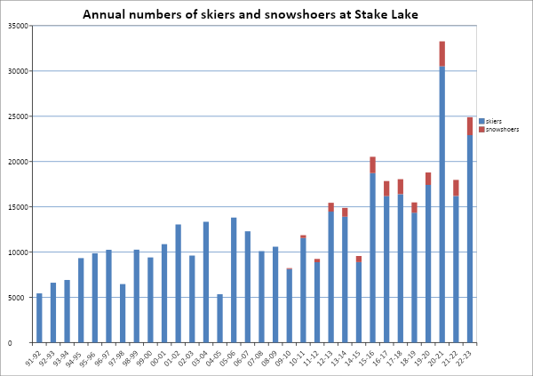

**7) FINANCIAL SUMMARY**

At the end of the club’s fiscal year on September 30th, 2023, revenues were $226,129, an 11% decrease over that earned last season. These revenues were from the sale of day passes and rental of ski and snowshoe equipment. A further estimated $50,000 was donated in volunteer labour bringing total revenue to $276,129. Operating expenses increased by 20% to $241,172 . Major expenses were employee wages and benefits, track setting and equipment, snow removal, insurance and fuel. Depreciation was estimated at $38,000 which results in total costs of $279,172. The club operated at a net operational loss of (15,043) and had a negative net income of (53,043).

The financial position of the club continues to be sound. Reserves are used to replace aging machinery, add to the pool of rental equipment and further improve trail facilities. Efforts continue to raise funds from granting agencies with some success.

The trail buildings include the washrooms, the day lodge or trailhead chalet and the machine maintenance building. A 1997 Bombardier Plus MP machine was purchased in December 2002 at a cost of $110,000. A new Prinoth Bison snow machine was purchased and delivered in March 2022. Two Arctic Bear Cat snow machines were purchased in 2019 and the two oldest snow machines were sold. The club now owns four small snow machines, three rollers and two Ginsu tracksetters.

The total value of assets held by the club, and used to operate the trails, now stands at $965,000. No debts are outstanding. Investments made by the Club over the past 30 years total approximately $1.6 million.

The Club continues to receive generous support from our funding partners. This year we received grants for solar lighting and for trail smoothing

**8) STAFF**

We thank our staff for their sustained efforts over the season and for representing us so well. Chelsea Francis returned as General Manager. She was supported by Hannah, the assistant manager. Other staff included Michael, Tracey, JD, Serena, Stacey, Shelley, Paisley, Zoe, Kady and Jack.

**9) TRAIL CONSTRUCTION, MAINTENANCE and LIGHTING**

No new ski trail construction took place, but regular trail maintenance continued. Volunteers removed debris and seedlings from all ski and snowshoe trails and brush cutting was carried out to cut back conifer seedlings and sitka alder. Poor drainage was corrected on a few trails and ATV access was blocked at the south end of the trails system.

Three new snowshoe trails, totalling 3.5 k, were constructed to the south of Stake Lake with support from Recreation Sites and Trails. These trails are named Spruce Canyon, Cow Creek and Rattler Viewpoint. Several “off-piste”, or ungroomed, ski trails were marked and checked for tree hazards.. The remaining 600m of Salix trail to the lookout was completed finalizing the off piste adventure trail network. All maps and signs were placed for the upcoming season.

100 volunteers spent approximately 500 hours cleaning the trails. Klaus Mey coordinated the work. Tim Cole and his trained chainsaw crew dealt with many fallen trees and debris on the snowshoe trails.

Building maintenance is another job that our volunteers take pride in accomplishing, and last fall, the trail shelters were renovated all with new roofs and new footings.

The club operates 57.7 km of ski trails including a 5 km dog trail, 20.7 km of snowshoe trails including a 2.6k dog trail, and 14.8 km of “off piste adventure” trails. 7 km of the ski trails have lights

**10) TREE REMOVAL AND LOGGING**

The OSC partnered with the BC Wildfire Service (BCWS) staff to assist the club in the removal of dead and danger trees that pose a safety risk to trail users. The BCWS removed approximately 100 trees throughout the network that was also used for training purposes for BCWS staff. This is the third consecutive year BCWS has assisted the OSC with this activity. Live and dead trees continue to fall on the trails, and all are removed each year by trail maintenance volunteers trained in the safe use of chainsaws.

**11) TRAIL GROOMING**

Trail grooming was again carried out by volunteer crews and by staff. Groomers were at work for 156 shifts. 18 individuals took part in the grooming for a total of 1160 hrs. The workload was much heavier than last year. Early heavy snow meant a longer grooming period and both snowcats were used throughout the season. Although the season length is reported as 118 days, grooming work began in the first week of November three weeks before the trails were opened to the public.

The work of maintaining the machines and setting the tracks sometimes seems never ending and we owe a huge vote of thanks to the crews.

**12) SNOW REMOVAL**

A local contractor was engaged to clear snow from the parking lot.

**13) EQUIPMENT**

The Bombardier snow cat again performed well this season but is showing its age. A second, new, Prinoth Bison snow machine was purchased and delivered at the end of last season. The Ginsu groomers, which are towed behind snowmobiles, were used to allow rapid touch up of trail conditions after heavy use days and proved invaluable during periods of low snowfall. Two Arctic Bearcat machines allow for more rapid trail rolling and tracksetting under early snow conditions and were used heavily this year because of the low snow conditions. 176 hours were spent maintaining the snow grooming equipment.

**14) BUILDINGS**

The club has built several permanent structures to operate the trail system. A day lodge is situated at the trailhead, with an upper floor for customers and a basement area for ski rentals and requires regular maintenance. Adjacent to the lodge is a separate washroom building. All our machinery used to operate the trails is stored in a large machine shed at the south end of Stake Lake close to the stadium area. A small cabin provides shelter in the Stadium area for officials during events and for younger children during lessons. The trailhead ticket booth provides office space for trail staff. Two small sheds were built for storing firewood. The Kamloops Astronomical Association uses a small observatory at the south end of the stadium to shelter a large telescope.

The large steel container (9’ x 40’) located in the Stadium area is used for storage for signs, fencing and direction boards used in races.

Our water system depends on a well located about 100m from the day lodge. The water must be treated to ensure it is safe for human consumption and constant maintenance of the treatment equipment in the washroom building requires considerable time and expertise.

**15) PROGRAMS and EVENTS**

Several events were held at the trails this year including the BC Winter Special Olympics with 27 athletes and the Okanagan Teck Cup with 125 athletes.

Overlander has made a special point of encouraging young people to learn to ski. We do not charge for children under 9 throughout the season and many children took advantage of this offer. We also run the Ski S’Kool program, which encourages school classes from grades 2-7 to come to the trails and take ski lessons free of charge. In past years, two classes travel to the trails each day and one class skis while the other snowshoes. This year attendance was affected by cancellations because of cold weather but 37 sessions were held for a record total of 1727 students.

Trails staff held a series of ski lessons for beginner and intermediate skiers. Well attended X sessions with 2 instructors and y participants

The Stuffie Ranger program continued for a third year. Children were encouraged to follow a map, either on skis or snowshoes, and find stuffies that had been hung alongside the trails. When they completed their map, they were awarded an Overlander Ski Club Stuffie Ranger Snowshoe or Ski badge, both of which had a cartoon moose on either skis or snowshoes wearing the club ski suit. This program continues to be successful.

**16) SKI AND SNOWSHOE RENTAL**

Skis and ski boots and snowshoes are rented from the basement of the day lodge. A further increase in inventory of high performance skis allowed us to provide more skiing opportunities for the public.

Skis were rented 1808 times and the pulks were rented on 58 occasions, both large increases compared to last season. However, the snowshoes rented 355 times which was a large decrease from last season.

**17) SAFETY**

Safety of clients, employees, volunteers and club members continues to be a high priority in our management plans and actions. The safety manual was updated. Staff and club members patrolled the trails on a regular basis. We continue to operate a check-in procedure for our employees when they are working on their own, in accordance with WorkSafe BC advice.

A chainsaw operator course and a snowmobile operator course were held for staff and volunteers to bring their ceritifcations up to date. We changed the requirement for first aid certifications for staff and raised the minimum to a Wilderness Advanced First Aid with preference for a Wilderness First Responder or OFA 3. The club instituted a new policy for assisting staff in paying for these courses.

11 minor incidents were reported this season. Several minor incidents were attributed to the “owl attacks”. There was a great horned owl that swooped several lone skiers in early January. This made news all over the province. Injuries were minor cuts and scrapes and one skier needed stitches. The trails where the owl frequented were closed and skiers were warned not to ski at night. The problem lasted only a couple weeks.

Accident in machine shed with snowmobile

**18) SECURITY**

Break-ins and vandalism are a constant concern. The Day Lodge and machine shed were equipped with alarm systems two years ago and were upgraded and video surveillance was installed.

Break in at machine shed

**19) CUSTOMER SUGGESTIONS**

Customer suggestions are received by staff either in person, by phone or by e-mail to a Club e-mail address. Trails contact information is posted on the club web page.

**20) RECOMMENDATIONS**

In 2023-24, with approval, the Overlander Ski Club will undertake to:

1. provide a safe and enjoyable experience for all skiers
2. increase opportunities for trail users to improve their skiing with club instructors
3. promote all operations with advertising materials including video
4. maintain snowshoe and off-piste ski trails to industry standards
5. improve ski trails by smoothing the running surface, filling wet spots and changing alignment to reduce accidents
6. name new trails and update trail maps
7. remove hazardous trees
8. purchase new radios, replace weather station and upgrade the fuel tank
9. hold an Overlander Loppet
10. increase trail fees for the new season to account for inflationary pressures
11. institute a charge for S’Kool Ski

All improvements will be paid for by the Overlander Ski Club and its supporters.

**21) ACKNOWLEDGMENTS**

Overlander Ski Club wishes to thank the staff of **Recreation Sites and Trails BC** for their co-operation throughout the year. We wish to thank Noelle Kekula and her staff for their efforts to ensure that Stake Lake Trails are managed in the best interests of the people of Kamloops and the Province. We also wish to express our appreciation to the TNRD for its generous grants to our lighting system improvements and numerous other supporters.

We also wish to thank:

* Our employees
* Our volunteers

The work of maintaining the machines and setting the tracks sometimes seems never ending and we owe a huge vote of thanks to the crews. This year they included: Thomas Bennett;; Tim Cole; Kavin Fleet; Mike Fleury; Debbie and Peter Findlay; Luc Guilherme; Chris Jones; Jason Ladyman; Al Long; Dana Manhard; Peter Prochotsky; Kerry Spear; Stu Stankewiecz; Mike Stewart-Smith; Peter Voss.

The trails also require work in the summer.  Klaus Mey and Tim Cole and his crew dealt with many fallen trees and debris on the snowshoe trails. Building maintenance is another issue that our volunteers take pride in accomplishing.

Many Club members provide an invaluable service by walking the trails in the fall to clear seedlings branches and rocks.

We also wish to thank:

* Runners Sole for their continued support of the snowshoe trails
* The Kamloops media for their assistance in publicising the winter activities of cross-country skiing and snowshoeing and the Stake Lake trail system.
* Tourism Kamloops
* Pacific Sport
* CCBC staff for their assistance throughout the year
* Funding agencies
* Cycle Logic for their generous donation to our new signage throughout the network

**APPENDIX A**

**Stake Lake Trails Financial Information for 2022-23**

|  |
| --- |
|  |
| Pass sales |  |
| |  |  | | --- | --- | | Ski day passes | 4540 | | Ski 6 day passes | 318 | | Night passes | 759 | | Disabled passes | 3 | | School visits | 1727 | | Snowshoe day passes | 1563 | | Snowshoe 6 Day passes | 4 | | Season ski passes | 1366 | | Season snowshoe passes | 40 | |  |
|  |  |
|  |  |
| Trail revenues *(Ski and snowshoe passes and ski rental)* |  |
| Ski passes: day and season passes  Snowshoe passes: day and season passes  Ski and snowshoe rental  Total Trail revenues  Volunteer labour donations | 199,190.00  5292.00  21,647.00  226,129.00  50,000 (estimated) |
| Total revenues | 276,129.00 |
|  |  |
| Trail Costs |  |
| Advertising and Promotion | 1,955 |
| Bookkeeping | 1,252 |
| Building maintenance | 9,427 |
| Debit machine | 919 |
| Depreciation | 38,000 (estimated) |
| Equipment, repairs and maintenance | 9,765 |
| Electricity | 6,788 |
| Freight | 0 |
| Fuel for tracksetting | 23,359 |
| General supplies | 7,199 |
| Insurance | 27,466 |
| Office supplies | 432 |
| Online payment fees | 2,423 |
| Signs | 9,560 |
| Snow removal | 6,844 |
| Ski rental equipment | 0 |
| Snowshoe rental equipment | 0 |
| Staff training | 4450 |
| Telephone and radio system | 4,214 |
| Ticket booth supplies | 0 |
| Trail maintenance | 0 |
| Travel | 10,764 |
| Volunteer labour donations | 50,000 (estimated) |
| Wages and benefits | 114,355 |
|  |  |
| Total costs excluding labour donations and depreciation | 241,172 |
| Total costs including depreciation | 279, 172 |
| Total costs including depreciation and labour donations |  |
|  |  |
| *net revenue or net loss* | 329,172 |
|  | (53,043) |

## APPENDIX B

## Trail use by user category

|  |  |  |  |  |  |  |  |  |  |  |  |  |  |  |  |  |  |  |  |  |  |  |  |  |  |  |  |  |  |  |  |  |  |  |  |  |  |  |  |  |  |
| --- | --- | --- | --- | --- | --- | --- | --- | --- | --- | --- | --- | --- | --- | --- | --- | --- | --- | --- | --- | --- | --- | --- | --- | --- | --- | --- | --- | --- | --- | --- | --- | --- | --- | --- | --- | --- | --- | --- | --- | --- | --- |
| |  |  | | --- | --- | | **2022-23** |  | |  |  | | Category | user days | | Senior | 2278 | | Adult | 14290 | | Student (included with Jr) |  | | Junior | 1441 | | Under 9 | 681 | | Night | 2492 | | Disabled Adult | 0 | | Disabled Junior | 0 | | Ski racers | 0 | | Group | 0 | | Ski S’Kool | 1727 | | Total | 22909 | |  |  | | Snowshoe | 1932 | | Snowshoe racers | 50 | | Total | 1982 |   **2021-22** | | |  |
|  | | |  |
| Category | user days |
| Senior | 1829 |
| Adult | 9519 |
| Student (included with Jr) |  |
| Junior | 832 |
| Under 9 | 1155 |
| Night | 2421 |
| Disabled Adult | 0 |
| Disabled Junior | 0 |
| Ski racers | 0 |
| Group | 0 |
| Ski S’Kool | 440 |
| Total | 16196 |
|  |  |
| Snowshoe | 1674 |
| Snowshoe racers | 100 |
| Total | 1774 |

**2020-21**

|  |  |
| --- | --- |
| Category | user days |
| Senior | 2482 |
| Adult | 19441 |
| Student | ? |
| Junior | 2422 |
| Under 9 | 718 |
| Night | 4958 |
| Disabled Adult | 1 |
| Disabled Junior | 5 |
| Ski racers | 0 |
| Group  Ski S’Kool | 0  492 |
| Total | 30519 |
|  |  |
| Snowshoe  Snowshoe racers  Total | 2763  0  2763 |

**2019-20**

|  |  |
| --- | --- |
| Category | user days |
| Senior | 1937 |
| Adult | 9005 |
| Student | 205 |
| Junior | 907 |
| Under 9 | 624 |
| Night | 2602 |
| Disabled Adult | 0 |
| Disabled Junior | 0 |
| Ski racers | 428 |
| Group  Ski S’Kool | 150  1558 |
| Total | 17416 |
|  |  |
| Snowshoe  Snowshoe racers  Total | 1298  75  1383 |

Note: these values are estimates from daily reports; reliability varies!

**APPENDIX C**

Packing early snow on Ricochet Nov 2022

|  |  |
| --- | --- |
|  | Overlander Wednesday Ladies trail clearing crew. |

Trail decorating crew Dec 2022

Snowshoe trails in November

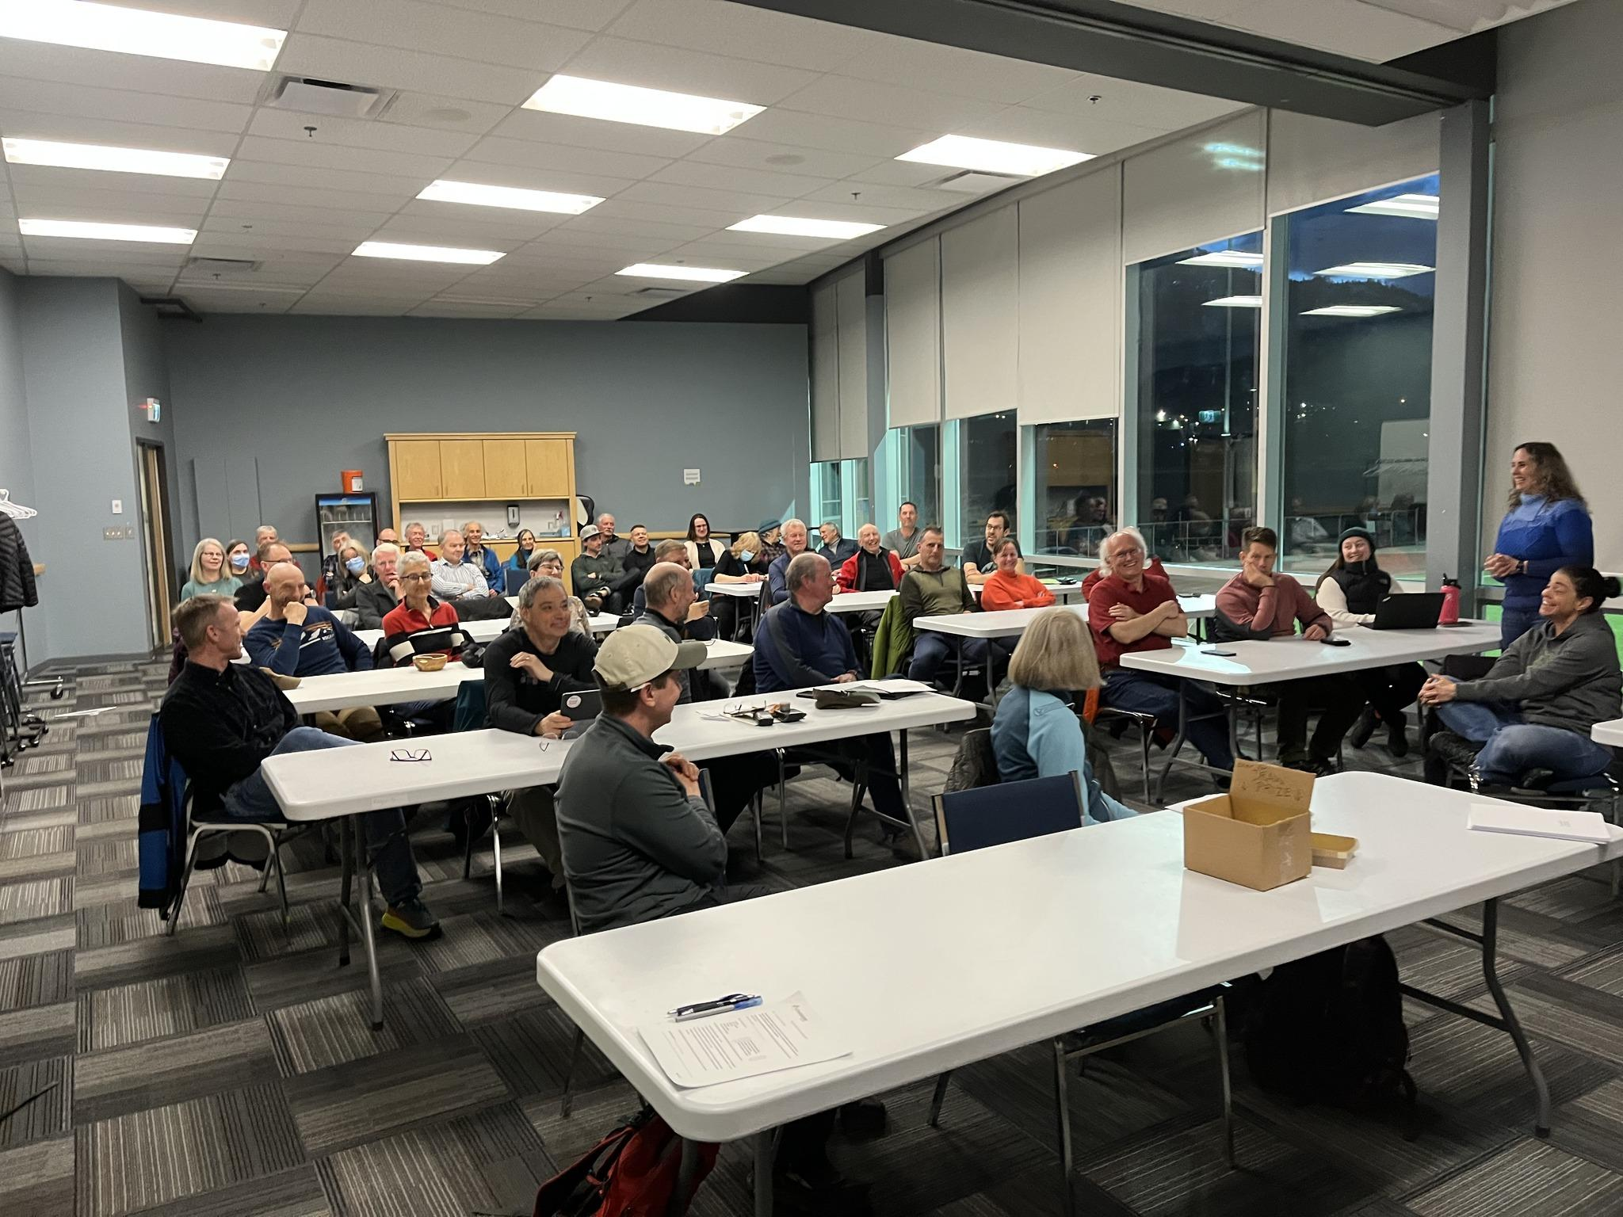

Our AGM on March 13th 2023

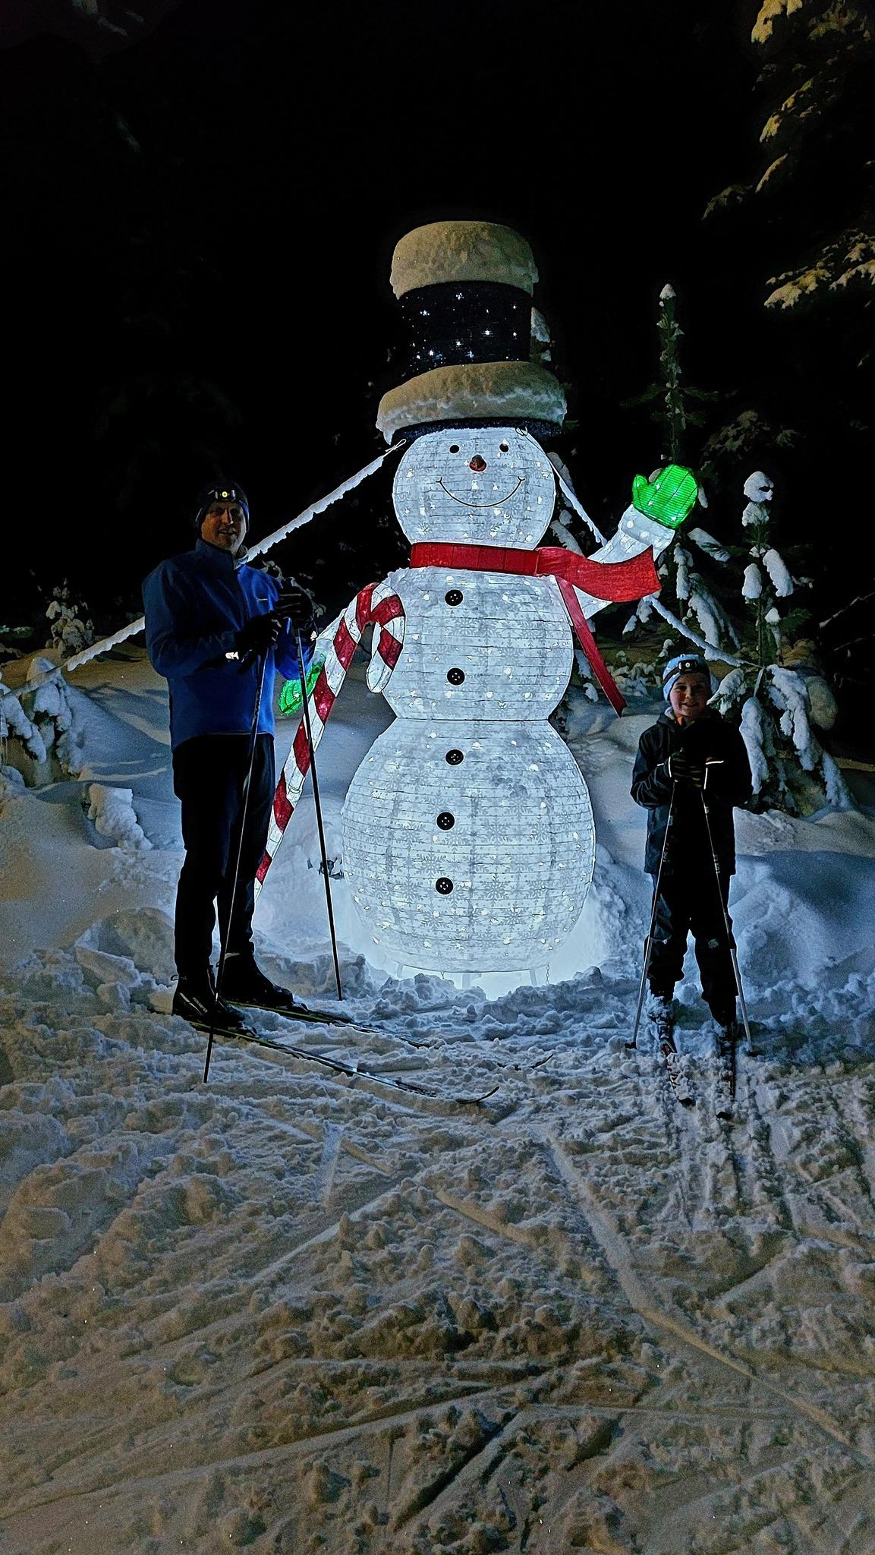Newest Christmas light addition

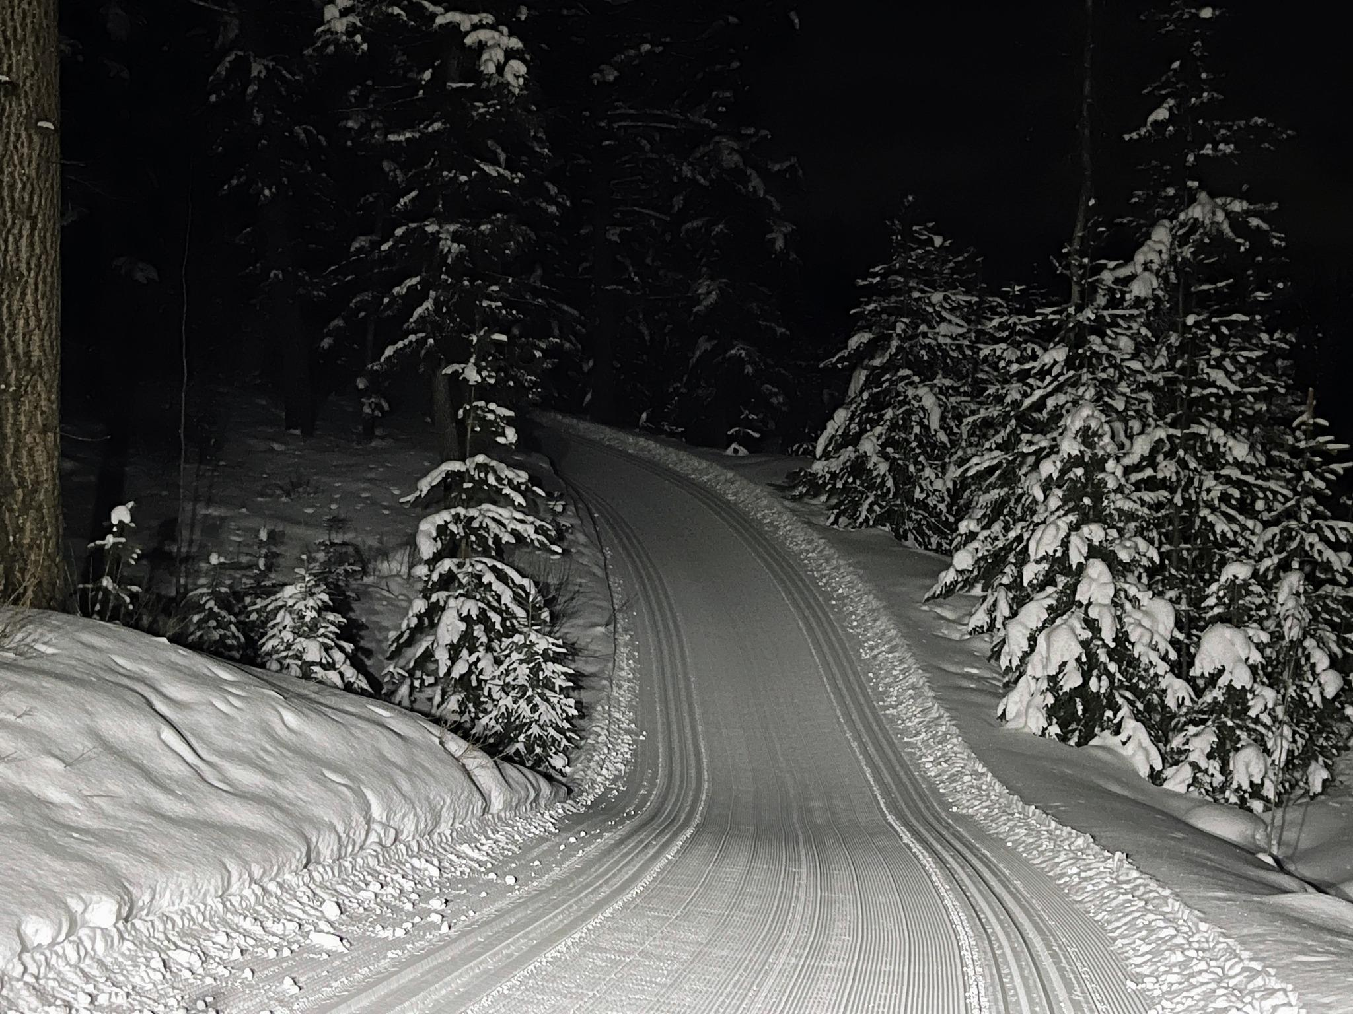

**Photo winner from our photo contest this year by our groomer, Thomas**

**APPENDIX D**

**TRAIL FEES 2022-23 (no change from 2019-20)**

|  |  |  |  |  |
| --- | --- | --- | --- | --- |
| Category | 6 day pass1 | day skiing | night skiing | snowshoe |
| Adult | 75 | 15 | 10 | 5 |
| Senior | 75 | 15 | 10 | 5 |
| Student | 35 | 7 | 5 | 2.50 |
| Junior | 35 | 7 | free | free |
| School groups | n.a. | free | free | free |
| <9 | free | free | free | free |

|  |  |  |  |  |
| --- | --- | --- | --- | --- |
| Category | Seasons Pass – Ski2 | | Seasons Pass – snow shoe2 | |
|  | early | regular | early | regular |
| Adult | 150 | 175 | 45 | 45 |
| Senior | 150 | 175 | 45 | 45 |
| Student | 72 | 82 | 22 | 22 |
| Junior | 72 | 82 | 22 | 22 |
| <9 | 15 | 15 | free | free |
| Family | 360 | 420 | n.a. | n.a. |
| Parent | 1003 | 100 | n.a. | n.a. |

1 no time limit to 6-day pass

2Includes OSC membership fee

3 for parents with children participating in Ski League programs

Season passes include night skiing. Skiers under 9 years of age ski free of charge. School groups ski free of charge. Rates for large groups or affiliated sports groups are available.

40 Years of Overlander Ski Club!

We won best outdoor/ recreation club in Kamloops for 2023