MEETING MINUTES
Overlander Ski Club

Date: Monday, February 6th, 2023
Time: 7:00PM
Location: Virtual

Attendees: Charlene Eden, Luc Guilherme, Dave Hallinan, Jen Stuart, Klaus Mey, Rich McCleary, Brad Smith, Chelsea Francis
Meeting started at 7:05 PM.

1.1 President’s Report
The club held a Teck Okanagan Cup on January 18th. This was our first race since the pandemic and it was great to get back into the swing of things with holding a small regional race! We had lots of participants from the Club including ski league kids and adults. This is also a great start to getting our ski league kids into racing!
February 3rd and 4th was the Special Olympics. This was an incredible two days that was so inspiring! As usual our club stepped up to volunteer to support the event and it was a huge success. To date the club has raised $680 through the club fundraiser for the purchase of a new snowmobile! CCBC has added an additional $100 to that for a total of $780!
1.2 Vice President’s Report
Over the past two months, there have been numerous meetings to move forth the work on governance and operations. These meetings have typically included myself, Dave and at times, Jen from the Board; Tim and Alan from the Trails Committee, our GM Chelsea, and at times Kim Christiansen. These meetings have been incredibly positive, informative and collaborative, with everyone involved clearly invested in working together. We have another meeting scheduled in March and will continue to meet regularly to work on governance and operations including finances. The governance committee is also hoping to have the bylaws draft done within the next 3-4 months.
I think it is important to note that I have received a substantial amount of positive feedback from members who know I now sit on the Board about the staff and in particular our General Manager, the amazing grooming this year, and the overall conditions and operations of OSC.
3.2 Finance Update
- Need to move banks - need to have online access, a local contact person, and a credit card. Better location would be great.
- $330,000 in the bank at the moment, $49,000 after fees in shopify sales.
- Shopify and Fareharbour platforms - needs separate access accounts for treasurer and staff.
- Tax package has been sent to the accountant, finalized version moving along and on its way. Tracy is more than comfortable shifting into a different approval process and accounts need to be carefully accounted for. Budget education training going to be needed to make sure the process works.

3.2 Registrar’s Report
Note: Since 2 people have registered twice, out total is really 1,415 not 1,417.
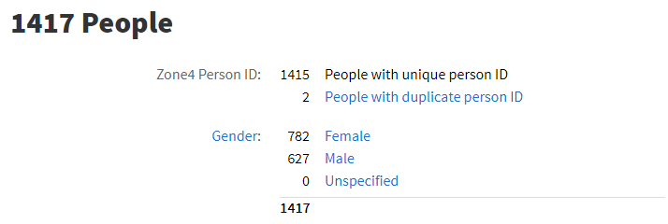
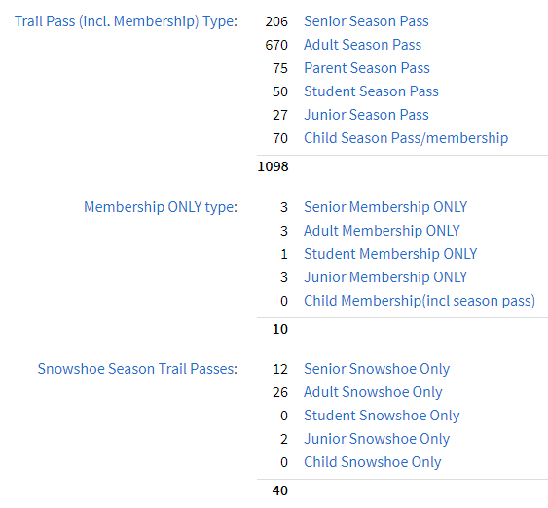
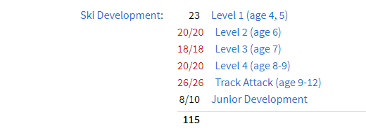
3.4 Volunteer’s Report
We just completed a very successful Special Olympics weekend with 25 athletes and 50 volunteers. Most of the volunteers were club members who put in about 600 volunteer hours over the weekend as well as leading up in prep work.
I would like to propose/request that we have a volunteer appreciation BBQ near the end of the season up at Stake Lake. Not sure what the cost would be, but I think we owe it to all the volunteers who help us out with our trails year after year. We would need several BBQs, some coolers for drinks, ideally somebody with food safe to wo/man the BBQ. I’ll see if somebody would like to help organize this as it will take a bit of work to pull this off. I could see if Fountain Tire would do the BBQing for us. they have a trailer with built in BBQ and have come out to other running events held by Runner’s Sole. I can inquire about cost for this. A food truck would be pretty costly.
Any suggestions re dates? A Saturday once lessons are over? Or maybe a Sunday when we don't have lessons.
5.2 Trails Report
- Graphs below of users numbers, we are keeping pace with 15-16, our second best year on record. We'll have past 15000 skiers by the time the board meeting rolls around here.
- Ski Skool is going really well, we have only had to cancel one class this year due to weather. Our Ski Skool gear has unfortunately taken a beating and has needed emergency replacements this season that weren’t in the budget. Our current gear was purchased in 17/18 and many items are approaching the end of their usable life (boots, snowshoes) We have had to purchase $5500 in ski boots to be able to see out the season. We also have several broken radios that need replacing, and 10 pairs of our older adult snowshoes that we use for the teachers and parents in the program.
- Lesson program is going great, approx. $3500 in gross revenue so far. Wallace Huston joined us as an instructor and his lessons have been getting great reviews, Roy Davidson and Serena Linsey have also been teaching lessons that have received great reviews. Laura Kalina, a level two coach, has also been offering a three week improve your skate skiing series that has been great. She is hoping to run this program for us again in the future.
- Snowshoe Yoga event was an awesome success with ten participants and great feedback, we will run another one at the end of February.
- Ski league waxing clinic coming up on February 11th.
- All our new trails signs are in and looking pretty, they will be installed after the trails close down.
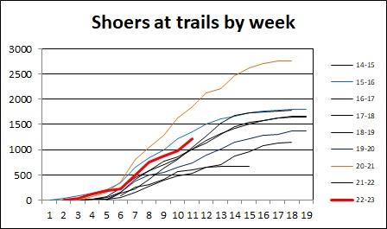
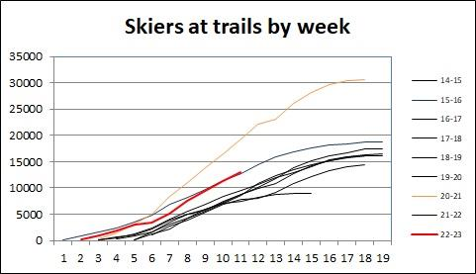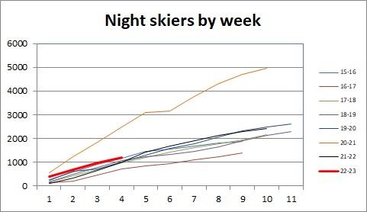

  - Agenda Items

- Strategy for applying for grant funding (Beattie – from previous board meeting)
- We need a stronger strategy for grants. What is our vision, how does this fit into our vision? We need the information and strategy in place before we apply for more grants. We don’t want incomplete grants going through and us getting ultimately shelfed. We need to set ourselves up for success.
- Discuss long-term planning and how we’d like to update and revise our “wishlist” (From previous board meeting)
- Strategic Planning meeting with Board, Trails committee and key volunteers needs to happen. Before this we need to do a membership survey to get the feedback of the membership to work with for the meeting.
- -Chelsea to draft up the survey and present to the board, needs to be out asap.
- Willing to pay someone to facilitate. Board has ideas of good candidates. Letter of engagement would be drafted and signed.
- Could have a strategic planning session in March or April facilitated by someone not from the Board or from the Trails Committee.

- AGM date and Plan (Francis)
- March 13th date. In person. Put out a newsletter regarding the AGM date and board nomination form.
- There will be cake at the AGM
- Chelsea to send out general schedule to the board on how the AGM has worked in the past. March 1st needs to be the deadline to run for the board.
- Digital package out by the Thursday prior to the board meeting.
- We need to draft a list of who has received it in the past and who needs to be nominated for it in the past. (service awards)
- Figure out what everyone is speaking about and in what order.
- Distinguished service award.
  - Vesta and Maureen have been nominated for the award.
- Staff recognition for 5 years of service. Chelsea to handle
  - Shelley Davidson had her five years last year. Chelsea to handle
- Venue booking.
  - Dave to look into West Highlands Park
  - Could host it as the TCC or the West Highlands community Center.
4. Sick pay policy (Francis)
Draft Policy: Overlander Ski Club will compensate contract employees 2 sick days per season. Past 90 days of continual employment in a season this becomes 5 days. Employer may request proof of illness for paid sick days to be paid out. In special cases Employees may apply for more on a case by case basis. Board agrees with this policy and it will be added to the manual.
- Need to amend covid policy in the Staff manual.
- This policy is based in Covid times, this was what we decided on during Covid, but moving forward think it would be a good thing to incorporate into staff policy if someone is truly sick.
5. Volunteer recognition, the club wants to send cards to the volunteers. Groomers have their lunch, coaches have their end of the year potluck, group getting missed is the event volunteers and the group that prunes.
6. Board member roles and responsibilities (Eden)

Meeting completed at 8:56 pm

